**Assign 1 - Your First Django Apps**

Justin Meek

Web Application Development, Fall 2022

ISQA 3900-850

Mrs. Sandra Vlasnik

September 18, 2022

**Submission Links**

GitHub Submission - <https://github.com/ISQA-3900/assign-1---your-first-django-apps-jmeekUNO.git>

GitHub Clone for PythonAnywhere - <https://github.com/jmeekUNO/assign-1-pythonanywhere.git>

SSH - [git@github.com:jmeekUNO/assign-1-pythonanywhere.git](mailto:git@github.com:jmeekUNO/assign-1-pythonanywhere.git)

PythonAnywhere - <https://jmeek.pythonanywhere.com>

**Functionality Screenshots**

Program deployed with python anywhere.

Library Home Screen with functional counters for books. Home button on left is stationary and will always take you back here.

Book list page that shows books, added from the admin page.

The admin page to manage the website.

Book detail page, which shows information related to the book clicked. As well as links the author page.

The author page I could not get to function. I am not sure what I did wrong. I do have the correlating html pages in my repositories. When you grade my work professor, I’d love to come back and get it working soon.

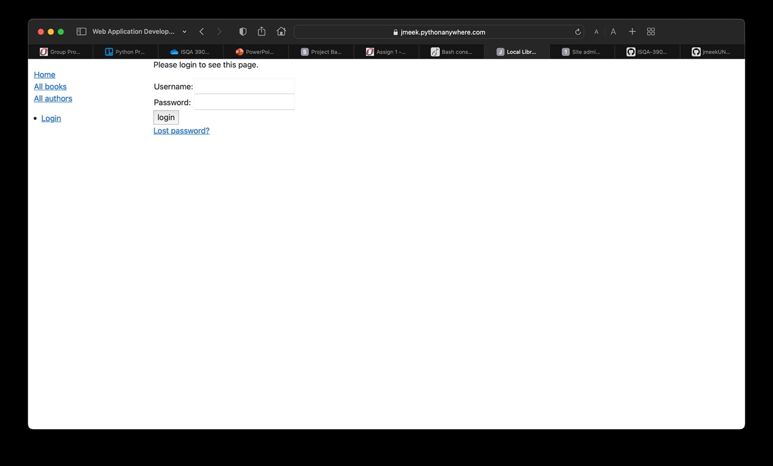

The login page. Superusers can be added via local program in pycharm, as well as within pythonanywhere once deployed. My own user is added (jmeek) as well as your (instructor) user.

Now logged into my account, as seen on the sidebar.

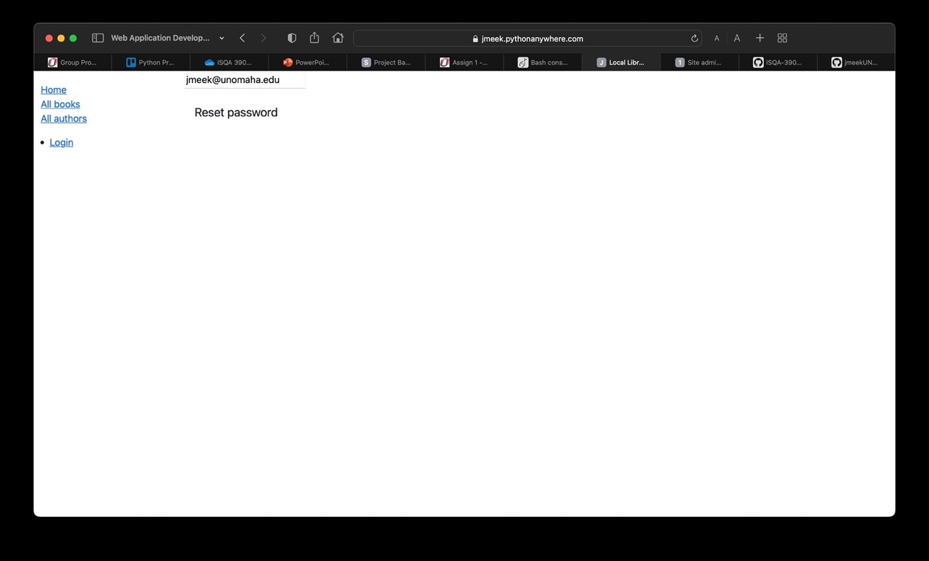

Reset password page.

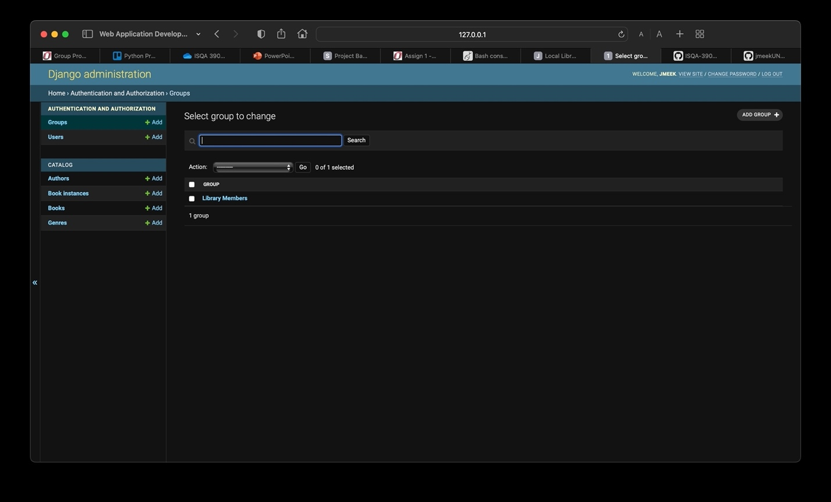

More screenshots showcasing the functions of the admin site. This is the group page to edit groups.

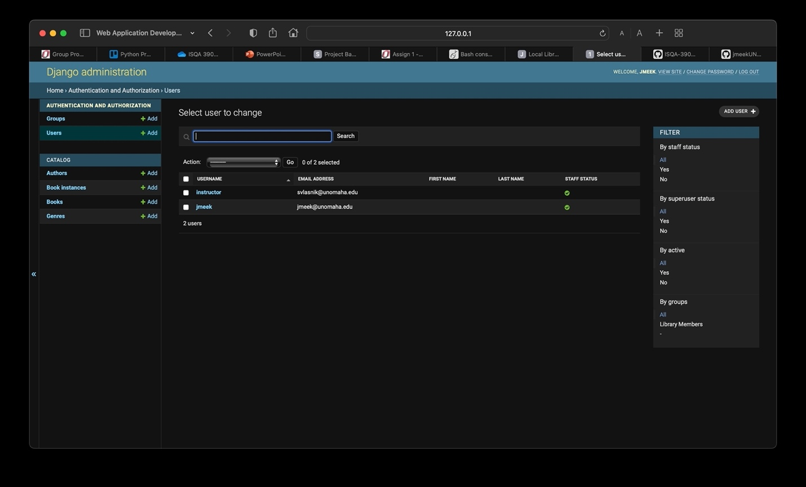

User page. Add/remove/edit users.

Book page. Same goes for instances and genres as well.

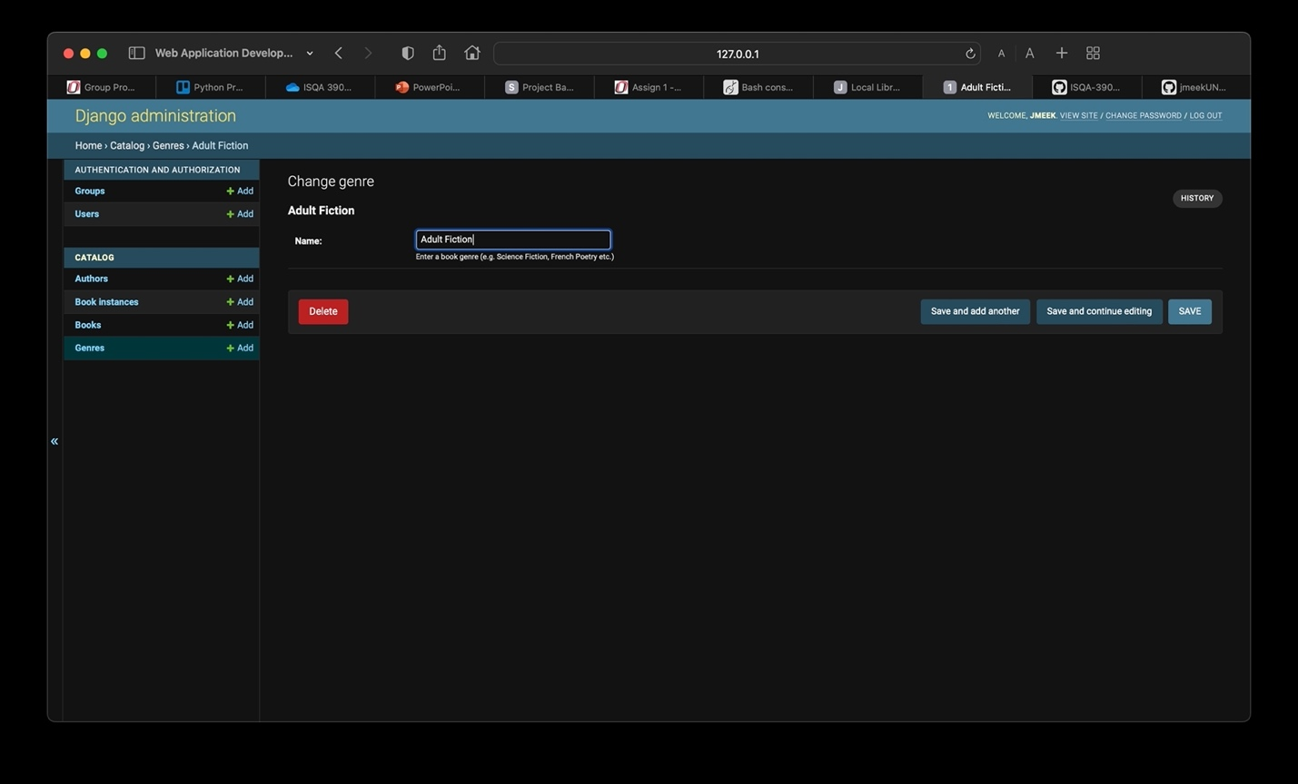

Updating a pre-existing genre.

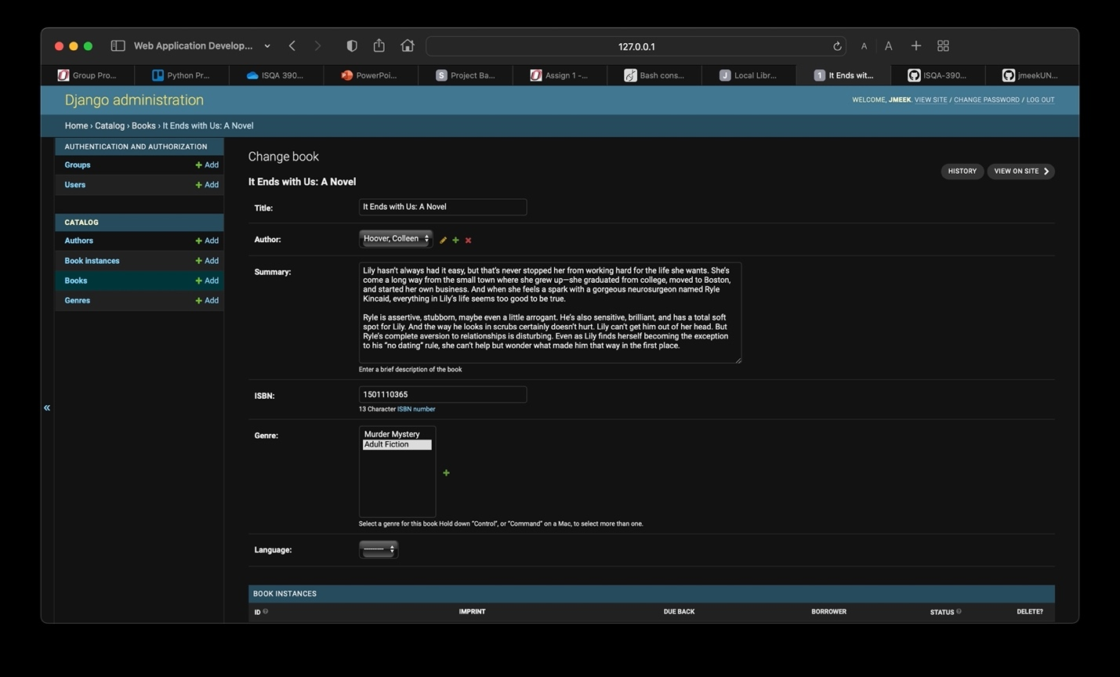

Updating a pre-existing book.

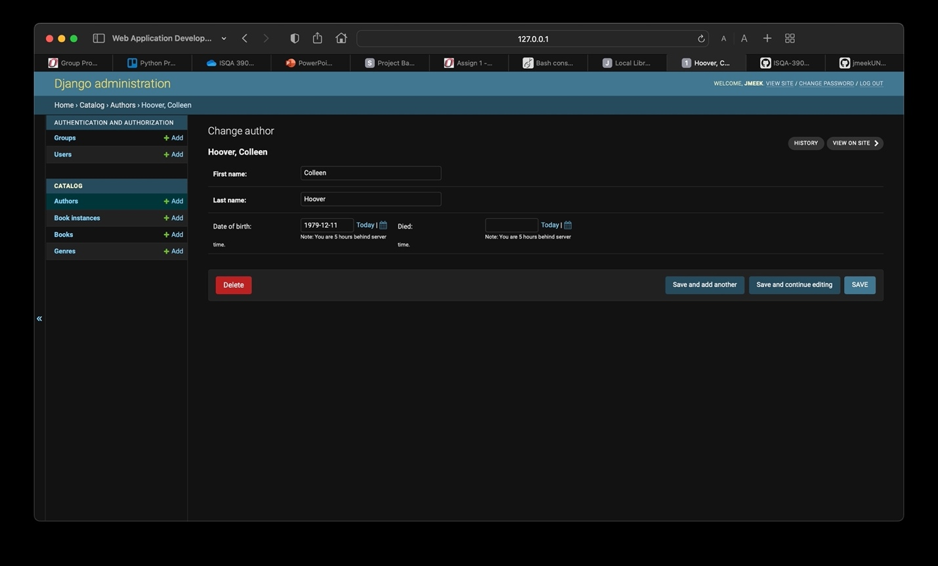

Updating a pre-entered author.